TITLE OF THE PAPER
(capital letters, centred, TNR, 14 points, bold)

1st AUTHOR, 2nd AUTHOR etc. *
(capital letters, centred, Times New Roman, 12 points, bold)

ABSTRACT: The Abstract will only be in English and will have between 100 and 150 words, a single, left-right alignment, Times New Roman, 10 points, italic.

KEY WORDS: 5-10 words, in English, Times New Roman, italics, 10 points.

JEL CLASSIFICATIONS: 2-5 codes, Times New Roman, 10 points, italic.
(http://www.aeaweb.org/jel/guide/jel.php)

1. THE TITLE OF THE CHAPTER
(capital letters, bold, Times New Roman, 11 points, numbered with Arabic numbers)

The paragraphs should be justified, single-spaced, and written in Times New Roman, 11 point regular font. The paper must be written in English and formatted on A4 paper (210 × 297 mm) with the following page settings: top and bottom margins of 4.6 cm, left and right margins of 3.7 cm, and header/footer margins of 1.27 cm, with different layouts for odd and even pages, as well as a different first page.
The <Tab> key should be set to 1.27 cm. The article should be between 8 and 14 pages in length, with an even number of pages (8, 10, 12, or 14), including figures, tables, references, and annexes. A blank line should be inserted both before the chapter title and between the title and the first line of the subsequent text.

1.1. Subchapter
(TNR, bold, 11 points, numbered with Arabic numbers)

The text begins in a new paragraph, separate from the subtitle, with an 11-point blank line between them.
Citations within the text should be formatted as follows:
- for one author: (McDonald, 2000) or (McDonald, 2000, p. 32) or (McDonald, 2000, pp. 32-33);
- for two authors: (Koch & McDonald, 2000) or (Koch & McDonald, 2000, p. 32) or (Koch & McDonald, 2000, pp. 32-33);
- for three or more authors: (Smith, et al., 2002) or (Smith, et al., 2002, p. 10) or (Smith, et al., 2002, pp. 10-12).
Figures and tables should be placed within the text in the order they are referenced, ideally on the same page. They must be numbered with Arabic numerals and include a title. High-contrast, black-and-white figures are preferred.

Table 1. Non-cash payments in the Eurozone in 2021

Payment methods | Number of payments  (in Billion) | Share  (%) | Value of payments  (in Trillion Euros) | Share  (%) | Value/ payment  (in Euros)
Credit transfers | 25.1 | 22 | 184.2 | 93 | 7,350
Direct Debits | 23.2 | 20 | 7.3 | 4 | 316
Cards | 54.8 | 49 | 3.3 | 2 | 60
E-money | 5.8 | 5 | 0.3 | <1 | 51
Cheque | 1.3 | 1 | 1.4 | 1 | 1,101
Others | 4.1 | 3 | 0.4 | <1 | 96
Total | 114.2 | 100 | 197.0 | 100 | 1,725
Source: European Central Bank Statistical Database, 2021

INCLUDEPICTURE "https://a.storyblok.com/f/88670/3841x2161/c2d0656868/why-sepa-instant-needs-nudge-coverage-europe.png/m/smart" \* MERGEFORMATINET INCLUDEPICTURE "https://a.storyblok.com/f/88670/3841x2161/c2d0656868/why-sepa-instant-needs-nudge-coverage-europe.png/m/smart" \* MERGEFORMATINET INCLUDEPICTURE "https://a.storyblok.com/f/88670/3841x2161/c2d0656868/why-sepa-instant-needs-nudge-coverage-europe.png/m/smart" \* MERGEFORMATINET 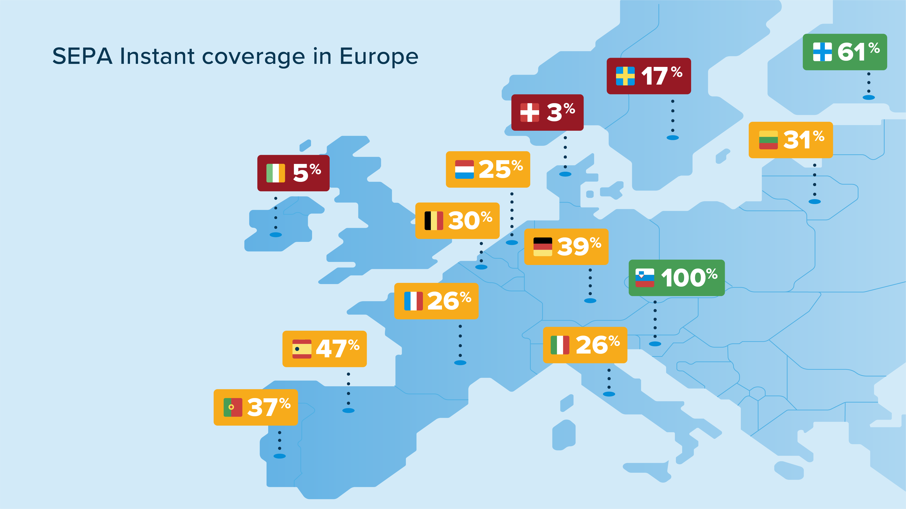
Source: Cazacu, A. (2022) Open Banking: Why SEPA Instant Payments Need a Nudge, TrueLayer, https://truelayer.com/blog/product/open-banking-why-sepa-instant-payments-need-a-nudge/

Figure 4. SEPA Instant coverage in Europe
The figure/table number and title should be written in Times New Roman, 10 points, bold, and centered. The title should be placed above tables and below figures. Table headings should be in Times New Roman, 10 points, bold, while the content should be in Times New Roman, 10 points, regular.
Mathematical equations should be written in Times New Roman, 11 points, regular, centred, and numbered on the right with Arabic numerals in round brackets.

X² + Y² = Z² (1)

References should be listed at the end of the paper in alphabetical order by the authors' last names. The following elements are required for each reference:
- books: Author’s surname, Initial of first name (Year) Title of book, Edition (only include this if not the first edition), Publisher, Place
- journal articles: Author’s surname, Initial of first name (Year) Title of article, Full Title of Journal, Volume number (Issue/Part number), Page numbers
- journal articles from an electronic source: Author’s surname, Initial of first name (Year) Title of article, Full Title of Journal, Volume number (Issue/Part number), Page numbers if availalble, Available at: include web site address/URL (Uniform Resource Locator), [Accessed date]
- newspaper articles: Author’s surname, Initial of first name (Year) Title of article, Full Title of Newspaper, Day and month before page numbers and column line
- websites: Authorship or Source (Year) Title of web document or web page, Available at: include web site address/URL(Uniform Resource Locator), [Accessed date]
References should be written in Times New Roman, 10 points, with a hanging indent of 1 cm, as shown in the example below:

REFERENCES:

[1]. Bruggink, D. (2020) European payments regulation: State of play at the start of the new decade, Journal of Payments Strategy & Systems, 14(1), pp. 32-39
[2]. Boughton, J.M. (2002) The Bretton Woods proposal: an indepth look, Political Science Quarterly, 42(6), Available at: http://www.pol.upenn/articles, [Accessed 20 January 2024]
[3]. Căpraru, B. (2023) Management bancar (Bank management), Editura C.H. Beck, Bucureşti
[4]. Greuning, H., Bratanovic, S. (2003) Analyzing and Managing Banking Risk, The World Bank, Washington
[5]. Koch, T., McDonald, S. (2000) Bank management, Harcourt Brace & Company, Orlando
[6]. Russell-Walling, E. (2009) Rethinking bankers' pay, The Banker, 5 October, p. 4
[7]. Wandhöfer, R. (2017) The Future of Digital Retail Payments in Europe: A Place for Digital Cash?, Journal of Payments Strategy & Systems, 11(3), pp. 248-258
[8]. Capgemini, World Payments Report, https://www.capgemini.com
[9]. Deloitte (2019) SEPA Instant Credit Transfer, https://www.deloitte.com
[10]. European Central Bank, Statistical Database
[11]. National Bank of Romania, Retail payments, https://www.bnr.ro/Retail-payments-3307.aspx, [Accessed 15 May 2014]
[12]. PricewaterhouseCoopers (2011) Global Private Banking and Wealth Management Survey,http://www.pwc.com/en_GX/gx/private-banking-wealth-mgmt-survey/pdf/Global-Private-Banking-Wealth-2011.pdf, [Accessed 15 May 2024]
[13]. European Union (2015) Regulation (EU) no. 2015/751 on interchange fees for card-based payment transactions, Official Journal of the European Union, L 123
[14]. http://www.privatebanking.com/, [Accessed 15 May 2024]

* 1st author’s academic and scientific title, affiliation, email address (TNR, 10 points, italic) 2nd author’s academic and scientific title, affiliation, email address (TNR, 10 points, italic) etc.

